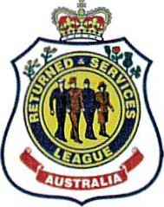
Returned and Services League of Australia (Queensland Branch) Gaythorne Sub-Branch Inc.
Community Welfare Fund
Support and Assistance
Guidelines and Applications

- Mission
The Returned and Services League of Australia (Queensland Branch) Gaythorne Sub-Branch Inc. (Gaythorne RSL) strives to be a highly respected and valued community supporter. One way we aim to achieve this is to provide financial assistance to the local community for individuals and groups to strive for pursuits of excellence.
- Process

Gaythorne RSL receives many requests for assistance from the community and veterans. The Finance Sub Committee assesses the requests and provides a recommendation to the Board of Directors.

These requests should be sent to the Secretary at secretary@gaythornersl.com.au or by post to Gaythorne RSL Sub-Branch Inc. PO Box 6361 Mitchelton Qld 4053.

Please note: Meeting the conditions set out by the Gaythorne RSL does not infer or oblige the RSL to provide financial assistance
- Eligibility Criteria
To be eligible for community assistance the applicant must:
- Give details of the Group/Organisation, (Defence Unit, Charity, Community Based Organisation, Sporting Club, or an individual with an educational goal).
- Be situated within the acknowledged demographical area of the Gaythorne RSL.
- Carry out business within the same area.
- Who or which group will benefit from the support or assistance
- Background to the request including history if applicable
- Contact name, telephone/mobile and email.
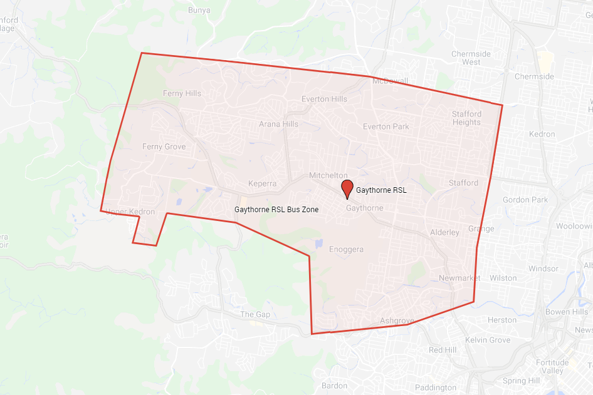

The Gaythorne RSL provides financial assistance of Community Support and Assistance by the group conducting raffles on a Friday night at the club. This policy outlines the application process to gain this opportunity.
These Friday night raffle nights are open to local not for profit community groups i.e.
Lions Clubs, School P and C/F’s and local Sports Clubs
The local group will provide two people to see raffle tickets on a Friday night between 5 and 7pm and the local group will be appointed for the entire month
Group selection at the sole discretion of Gaythorne RSL and a local group may be appointed multiple times in a year
- Guidelines for Community
Community Groups can make an amount of up to $2,000 each month from the raffles depending on the sales of raffle tickets
Gaythorne RSL will provide the following: -
- Meat Trays and or prizes
- Till Draw and Float
- Raffle Tickets
- Tickets to sell for $2 each or three for $5
- A table and chairs
- Help with the ticket draws

The Group supplies
The staff to sell the tickets and do the draw and handover the prize and explain that the staff can hold the prize in the fridge for the winner until they are ready to leave

Proceeds of the ticket sales
Gaythorne RSL will recover the cost of the float, meat trays, or raffle prizes from the ticket sales
The remainder of the ticket sale will be payable to the local group. Payment will be made at the end of each month via EFT payment

